**Pulp Magazines**

Pulp magazines are named for the low-quality pulpwood paper on which they were printed. They are part of the modernist periodical marketplace along with the slicks, published on glossy paper, and little magazines. The age of the all-fiction pulp magazine in the U.S. extends from 1896 to 1955. The low cost of pulpwood paper, advances in printing technology, expansions in the postal system, and streamlined distribution methods enabled the pulps to reach readers everywhere. Their cover prices, between ten and twenty five cents, also made them affordable. The pulps are vital components of the popular culture of the modernist era. In addition to fostering the development of genre fiction, the pulps reprinted earlier works, helped construct communities of readers and writers, and launched many careers.

**The Rise of the Pulps**

The first all-fiction pulp magazine is the December 1896 issue of Frank A. Munsey’s *The Argosy*. Within ten years *The Argosy*’s circulation reached 500,000 a month, leading Munsey to expand his pulp offerings. *The All Story Magazine* debuted in 1905 and *The Cavalier* in 1908. *The Argosy*’s success invited the attention of competitors, including Street & Smith’s *The Popular Magazine* (1903) and *People’s Magazine* (1906) and Story-Press’s *The Blue Book Magazine* (1907) and *The Green Book Album* (1909).

In November 1910 the Ridgway Corporation published the first issue of *Adventure*, which became the leading pulp magazine in the U.S. A crucial moment in the early history of the pulps is *All Story*’s publication of Edgar Rice Burroughs’s *Tarzan of the Apes* in October 1912. By 1922, a key year in modernist studies, thirty five pulp titles were being published and that number would only rise until the Great Depression began to affect pulp publishers in 1932.

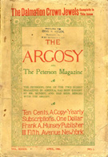

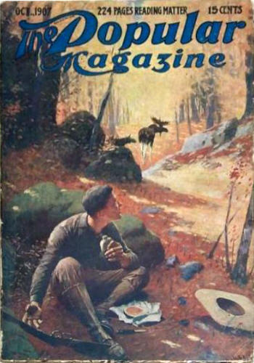

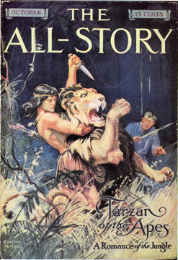

**Genre Specific Pulp Magazines**

Beginning in 1915, genre specific titles began to proliferate, creating niches markets for detective stories, science fiction, westerns, romances, horror, fantasy, and a broad range of generic hybrids. Street & Smith led the way with *Detective Story Magazine* in 1915, *Western Story Magazine* in 1919, and *Love Story Magazine* in 1921. The most important detective pulp, *Black Mask*, debuted in 1920, providing an outlet for the hardboiled work of Dashiell Hammett and Raymond Chandler. Hero pulps, like *The Shadow*, emerged out of the detective pulps.

While many new magazines entered established markets or combined existing styles to court a niche market, such as *Spicy Detective*, which specialized in erotic detective stories, others created new genres and markets. One such magazine, *Weird Tales*, debuted in March 1923 because its founding publisher, Jacob Clark Hennenberger, wanted to provide a venue for fiction that did not fit the conventions of other pulps. Farnsworth Wright became the editor of *Weird Tales* in November 1924; during his run as editor he provided a venue work by H. P. Lovecraft, Robert E. Howard, and Robert Bloch.

The pulps also play a crucial role in the development of science fiction. In 1926 Hugo Gernsback’s *Amazing Stories* became the first pulp devoted to scientifiction, which Gernsback later renamed science fiction. Gernsback had previously published science fiction in his popular science magazines like *Modern Electrics*. The early success of *Amazing Stories* paved the way for *Astounding Stories*, the most influential science fiction pulp. Renamed *Astounding Science Fiction* at the beginning of the editorial run of John W. Campbell in 1938, the magazine launched the careers of Isaac Asimov, Robert A. Heinlein, and L. Ron Hubbard.



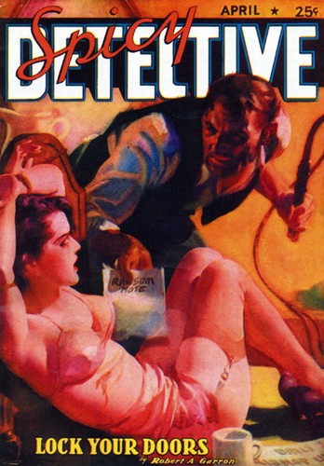



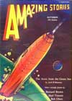

**The Decline of the Pulps**

Although the pulps saturated the print marketplace in the 1930s, they also experienced increased competition from comic books and paperbacks. During the Second World War many pulps ceased publication and even those that survived emerged into a transformed marketplace. *Adventure*, *Argosy*, and *The Blue Book* all rebranded themselves as men’s magazines in the 1950s to varying degrees of success. By the middle or the 1950s pulps had become scarce and an era of popular publishing had come to an end.

**Print References**

Ashley, Michael. *The Time Machines: The Story of the Science-Fiction Pulp Magazines from the Beginning to 1950* (Liverpool: Liverpool UP, 2000)

Earle, David. *Re-Covering Modernism: Pulps, Paperbacks, and the Prejudice of Form* (Surrey: Ashgate, 2009)

Peterson, Theodore. *Magazines in the Twentieth Century* (Urbana: U of Illinois P, 1964)

**Web Resources**

The Pulp Magazine Project (hosts entire scanned issues of pulp magazines and contextual essays at [www.pulpmags.org](http://www.pulpmags.org))

The Virtual 1925 Newsstand (a digital archive at the University of West Florida that reproduces the range of magazines available on newsstands in 1925 at <http://uwf.edu/dearle/enewsstand/enewsstand.htm>)